27.06.2008
Name :
Number :

CEM12X LOGIC EXAM

( 25 ) |  | Design a synchronous counter  If the input x=0 the counter sequence: 1,3,0  If the x=1 the counter sequence : 2,1,0  - Design the counter using JK flip flops  - Determine the behavior of the circuit in the case of entering unused states.
( 5 ) |  | Give 3 advantages of digital systems over analog systems.
( 10 ) |  | Simplify the given expression by using only Boolean Algebra
( 10 ) |  | For the following ASM chart write the type, the state diagram and state table.  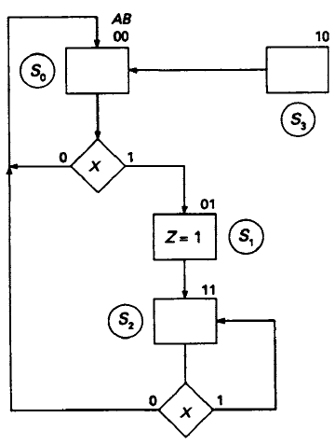
( 10 ) |  | Convert the following numbers from the given base to the other three bases indicated  - (10111101,0101) ₂ =( ? ) ₈ = ( ? ) ₁₀  - (25,615)₁₀ = ( ? ) ₁₆ = ( ? ) ₂
( 10 ) |  | Convert the decimal number - 5.105 x 10 ² to a single-precision floating-point binary number
(10) |  | Implement the F function using a 3:8 decoder with a OR gate.  F(A,B,C)=ABC + A’BC + AC’
(5) |  | Convert binary 1 0 1 0 1 1 0 0 to Gray code
(10) |  | For 4M words memory, how many data input, data output and address lines should be used? Assume that word size is 8 bits.
( 5 ) |  | Hexadecimal numbers D6 will be transferred with a parity bit. What is the even parity bit?

